Group no: 7

1. Faiza Tasnim-(19-41552-3)
2. Syeda Faiza Karima-(20-43073-1)
3. Sharia Tasnim Adrita-(20-41895-1)
4. Sadia Afrin Sara – (20-41834-1)

|  |  |  |
| --- | --- | --- |
| **ID** | **Task** | **Member** |
| 1 | **Requirement Analysis** | FAIZA, SARA, KARIMA |
| 2 | Requirement Settings | KARIMA |
| 3 | Document Current System | FAIZA, KARIMA |
| 4 | Analysis Finished | SARA, KARIMA |
| 5 | **Design** | FAIZA, SARA, KARIMA, ADRITA |
| 6 | Use Case Diagram | FAIZA, SARA |
| 7 | Activity Diagram | FAIZA, ADRITA, SARA |
| 8 | Mock Design | FAIZA, ADRITA, SARA |
| 9 | Class Diagram | KARIMA, SARA |
| 10 | Design Finished | FAIZA, SARA, KARIMA, ADRITA |
| 11 | **Coding** | FAIZA, SARA, KARIMA, ADRITA |
| 12 | Develop System Module | SARA |
| 13 | Integrate System Module | ADRITA |
| 14 | Perform Initial Testing | KARIMA |
| 15 | Coding Finished | FAIZA |
| 16 | **Testing** |  |
| 17 | Perform System Testing |  |
| 18 | Document Issues Found |  |
| 19 | Correct Issues Found |  |
| 20 | Testing Finished |  |
| 21 | **Implementation** |  |
| 22 | On-site installation |  |
| 23 | Support plan for the system |  |
| 24 | Implementation Finished |  |
| 25 | **Documentation** |  |
| 26 | System Maintenance |  |
| 27 | Evaluation |  |
| 28 | Documentation Finished |  |

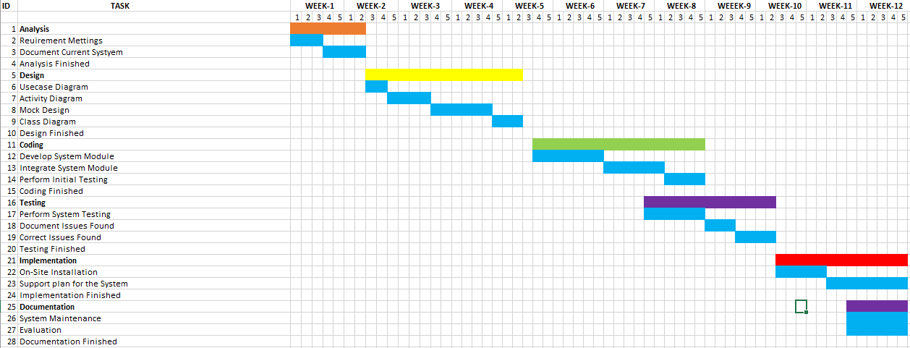

**Constructive Model for Emergency Medicare System:**

* **Project type: Semi-detached**
* **SLOC = 10000**
* **Coefficient<effort factor> =3**
* **P= 1.12**
* **Effort= PM= Coefficient<effort factor> *(SLOC/1000) ^P**

**=3*(10000/1000) ^1.12 =39.54**

* **Development Time= DM= 2.50*(PM)^T**

**=2.50*(39.54) ^0.35=9.05**

* **Required number of people =ST= PM/DM = 39.54/9.05=4.36**

**Budgeting:**

* **Development salary 9 month: Considering 600 taka per developer**
* **600*1584=950400 taka**
* **Requirement analysis: Hourly=400 taka**
* **Analysis expense=400*176=70400 taka**
* **Transportation cost: 15500 takas**
* **Training and hardware cost: 150000 takas**
* **Rent expense: 18000*9=162000 taka**
* **Total utilities: 60000 takas**
* **Maintenance cost: Expense per hour =1500 taka**
* **Extra hour needs for maintenance 80 hours**
* **Total maintenance = 80 * 1500=120000 taka**

* **Other human resource: Project manager = 1* 28000*9=252000 taka**
* **Accountant = 1* 22000*9=198000 taka**
* **Technical staff = 2* 15000*9=270000 taka**
* **Total cost= 252000+198000 +270000=720000 taka**
* **Total estimate expense: 950400+70400+15500+150000+162000+60000+120000+720000=2248300 taka**
* **Profit: 2248300*25%= 562075taka**
* **Final project budget: 2248300+562075=2810375 taka**